SOFT COMPUTING
ASSIGNMENT -10

Perumalla Dharan

AP21110010201

import tensorflow as tf
from tensorflow.keras import layers, models
from tensorflow.keras.datasets import cifar10
from tensorflow.keras.utils import to_categorical
import matplotlib.pyplot as plt
# Load CIFAR-10 dataset
(x_train, y_train), (x_test, y_test) = cifar10.load_data()
x_train, x_test = x_train / 255.0, x_test / 255.0 # Normalize images
y_train, y_test = to_categorical(y_train, 10), to_categorical(y_test, 10) # One-hot encode labels
# Function to plot training history
def plot_history(history, title):
plt.plot(history.history['accuracy'], label='train accuracy')
plt.plot(history.history['val_accuracy'], label='test accuracy')
plt.title(title)
plt.xlabel('Epochs')
plt.ylabel('Accuracy')
plt.legend()
plt.show()
# AlexNet Model
def build_alexnet():
model = models.Sequential()
model.add(layers.Conv2D(96, (3, 3), activation='relu', padding='same', input_shape=(32, 32, 3)))
model.add(layers.MaxPooling2D((2, 2)))
model.add(layers.Conv2D(256, (3, 3), activation='relu', padding='same'))
model.add(layers.MaxPooling2D((2, 2)))
model.add(layers.Conv2D(384, (3, 3), activation='relu', padding='same'))
model.add(layers.Conv2D(384, (3, 3), activation='relu', padding='same'))
model.add(layers.Conv2D(256, (3, 3), activation='relu', padding='same'))
model.add(layers.MaxPooling2D((2, 2)))
model.add(layers.Flatten())
model.add(layers.Dense(4096, activation='relu'))
model.add(layers.Dropout(0.5))
model.add(layers.Dense(4096, activation='relu'))
model.add(layers.Dropout(0.5))
model.add(layers.Dense(10, activation='softmax'))
return model
# LeNet Model
def build_lenet():
model = models.Sequential()
model.add(layers.Conv2D(6, (5, 5), activation='relu', input_shape=(32, 32, 3)))
model.add(layers.AveragePooling2D(pool_size=(2, 2))) # Specify pool_size
model.add(layers.Conv2D(16, (5, 5), activation='relu'))
model.add(layers.AveragePooling2D(pool_size=(2, 2))) # Specify pool_size
model.add(layers.Flatten())
model.add(layers.Dense(120, activation='relu'))
model.add(layers.Dense(84, activation='relu'))
model.add(layers.Dense(10, activation='softmax'))
return model
# VGGNet Model
def build_vggnet():
model = models.Sequential()
model.add(layers.Conv2D(64, (3, 3), activation='relu', padding='same', input_shape=(32, 32, 3)))
model.add(layers.Conv2D(64, (3, 3), activation='relu', padding='same'))
model.add(layers.MaxPooling2D((2, 2)))
model.add(layers.Conv2D(128, (3, 3), activation='relu', padding='same'))
model.add(layers.Conv2D(128, (3, 3), activation='relu', padding='same'))
model.add(layers.MaxPooling2D((2, 2)))
model.add(layers.Conv2D(256, (3, 3), activation='relu', padding='same'))
model.add(layers.Conv2D(256, (3, 3), activation='relu', padding='same'))
model.add(layers.Conv2D(256, (3, 3), activation='relu', padding='same'))
model.add(layers.MaxPooling2D((2, 2)))
model.add(layers.Conv2D(512, (3, 3), activation='relu', padding='same'))
model.add(layers.Conv2D(512, (3, 3), activation='relu', padding='same'))
model.add(layers.Conv2D(512, (3, 3), activation='relu', padding='same'))
model.add(layers.MaxPooling2D((2, 2)))
model.add(layers.Conv2D(512, (3, 3), activation='relu', padding='same'))
model.add(layers.Conv2D(512, (3, 3), activation='relu', padding='same'))
model.add(layers.Conv2D(512, (3, 3), activation='relu', padding='same'))
model.add(layers.MaxPooling2D((2, 2)))
model.add(layers.Flatten())
model.add(layers.Dense(4096, activation='relu'))
model.add(layers.Dropout(0.5))
model.add(layers.Dense(4096, activation='relu'))
model.add(layers.Dropout(0.5))
model.add(layers.Dense(10, activation='softmax'))
return model
# ResNet Model
def build_resnet():
def resnet_block(x, filters, kernel_size):
shortcut = x
x = layers.Conv2D(filters, kernel_size, padding='same')(x)
x = layers.BatchNormalization()(x)
x = layers.ReLU()(x)
x = layers.Conv2D(filters, kernel_size, padding='same')(x)
x = layers.BatchNormalization()(x)
x = layers.add([x, shortcut])
x = layers.ReLU()(x)
return x
input_tensor = layers.Input(shape=(32, 32, 3))
x = layers.Conv2D(16, (3, 3), padding='same')(input_tensor)
x = layers.BatchNormalization()(x)
x = layers.ReLU()(x)
for _ in range(3):
x = resnet_block(x, 16, (3, 3))
x = layers.GlobalAveragePooling2D()(x)
x = layers.Dense(10, activation='softmax')(x)
model = models.Model(input_tensor, x)
return model
# Compile and train models
def train_model(model, model_name):
model.compile(optimizer='adam', loss='categorical_crossentropy', metrics=['accuracy'])
history = model.fit(x_train, y_train, epochs=10, batch_size=64, validation_data=(x_test, y_test), verbose=1)
plot_history(history, model_name)
return model.evaluate(x_test, y_test, verbose=0)
# Main execution
def main():
models_dict = {
"AlexNet": build_alexnet(),
"LeNet": build_lenet(),
"VGGNet": build_vggnet(),
"ResNet": build_resnet(),
}
results = {}
for name, model in models_dict.items():
print(f"Training {name}...")
results[name] = train_model(model, name)
print("\nModel Comparison (Test Loss and Accuracy):")
for name, (loss, accuracy) in results.items():
print(f"{name}: Loss = {loss:.4f}, Accuracy = {accuracy:.4f}")
if __name__ == "__main__":
main()
C:\Users\136442\anaconda3\Lib\site-packages\keras\src\layers\convolutional\base_conv.py:107: UserWarning: Do not pass an `input_shape`/`input_dim` argument to a layer. When using Sequential models, prefer using an `Input(shape)` object as the first layer in the model instead.
super().__init__(activity_regularizer=activity_regularizer, **kwargs)
Training AlexNet...
Epoch 1/10
782/782 ━━━━━━━━━━━━━━━━━━━━ 544s 681ms/step - accuracy: 0.2645 - loss: 1.9612 - val_accuracy: 0.5375 - val_loss: 1.2943
Epoch 2/10
782/782 ━━━━━━━━━━━━━━━━━━━━ 491s 628ms/step - accuracy: 0.5377 - loss: 1.2746 - val_accuracy: 0.6120 - val_loss: 1.0883
Epoch 3/10
782/782 ━━━━━━━━━━━━━━━━━━━━ 491s 628ms/step - accuracy: 0.6338 - loss: 1.0347 - val_accuracy: 0.6649 - val_loss: 0.9610
Epoch 4/10
782/782 ━━━━━━━━━━━━━━━━━━━━ 496s 634ms/step - accuracy: 0.6900 - loss: 0.8940 - val_accuracy: 0.6976 - val_loss: 0.8937
Epoch 5/10
782/782 ━━━━━━━━━━━━━━━━━━━━ 491s 628ms/step - accuracy: 0.7315 - loss: 0.7768 - val_accuracy: 0.7080 - val_loss: 0.8340
Epoch 6/10
782/782 ━━━━━━━━━━━━━━━━━━━━ 490s 627ms/step - accuracy: 0.7539 - loss: 0.7082 - val_accuracy: 0.7085 - val_loss: 0.8631
Epoch 7/10
782/782 ━━━━━━━━━━━━━━━━━━━━ 489s 625ms/step - accuracy: 0.7812 - loss: 0.6264 - val_accuracy: 0.7283 - val_loss: 0.8051
Epoch 8/10
782/782 ━━━━━━━━━━━━━━━━━━━━ 494s 632ms/step - accuracy: 0.8022 - loss: 0.5659 - val_accuracy: 0.7415 - val_loss: 0.7688
Epoch 9/10
782/782 ━━━━━━━━━━━━━━━━━━━━ 490s 627ms/step - accuracy: 0.8215 - loss: 0.5163 - val_accuracy: 0.7403 - val_loss: 0.7971
Epoch 10/10
782/782 ━━━━━━━━━━━━━━━━━━━━ 491s 628ms/step - accuracy: 0.8358 - loss: 0.4714 - val_accuracy: 0.7497 - val_loss: 0.7854
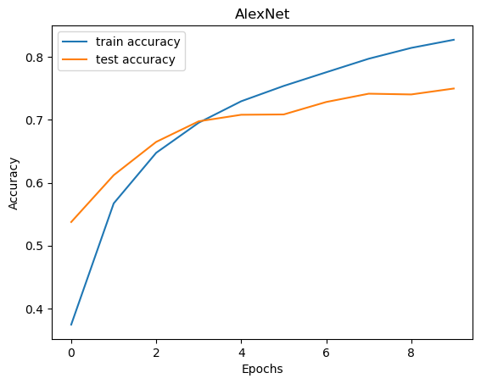
Training LeNet...
Epoch 1/10
782/782 ━━━━━━━━━━━━━━━━━━━━ 7s 6ms/step - accuracy: 0.3031 - loss: 1.9105 - val_accuracy: 0.4652 - val_loss: 1.4908
Epoch 2/10
782/782 ━━━━━━━━━━━━━━━━━━━━ 4s 5ms/step - accuracy: 0.4662 - loss: 1.4714 - val_accuracy: 0.5034 - val_loss: 1.3903
Epoch 3/10
782/782 ━━━━━━━━━━━━━━━━━━━━ 4s 6ms/step - accuracy: 0.5135 - loss: 1.3577 - val_accuracy: 0.5333 - val_loss: 1.3244
Epoch 4/10
782/782 ━━━━━━━━━━━━━━━━━━━━ 4s 6ms/step - accuracy: 0.5438 - loss: 1.2805 - val_accuracy: 0.5412 - val_loss: 1.2842
Epoch 5/10
782/782 ━━━━━━━━━━━━━━━━━━━━ 4s 5ms/step - accuracy: 0.5662 - loss: 1.2267 - val_accuracy: 0.5535 - val_loss: 1.2333
Epoch 6/10
782/782 ━━━━━━━━━━━━━━━━━━━━ 4s 6ms/step - accuracy: 0.5769 - loss: 1.1837 - val_accuracy: 0.5527 - val_loss: 1.2505
Epoch 7/10
782/782 ━━━━━━━━━━━━━━━━━━━━ 5s 6ms/step - accuracy: 0.5904 - loss: 1.1416 - val_accuracy: 0.5303 - val_loss: 1.3449
Epoch 8/10
782/782 ━━━━━━━━━━━━━━━━━━━━ 4s 5ms/step - accuracy: 0.6075 - loss: 1.1053 - val_accuracy: 0.5521 - val_loss: 1.2713
Epoch 9/10
782/782 ━━━━━━━━━━━━━━━━━━━━ 4s 6ms/step - accuracy: 0.6206 - loss: 1.0648 - val_accuracy: 0.5838 - val_loss: 1.1789
Epoch 10/10
782/782 ━━━━━━━━━━━━━━━━━━━━ 4s 5ms/step - accuracy: 0.6293 - loss: 1.0418 - val_accuracy: 0.5815 - val_loss: 1.2003
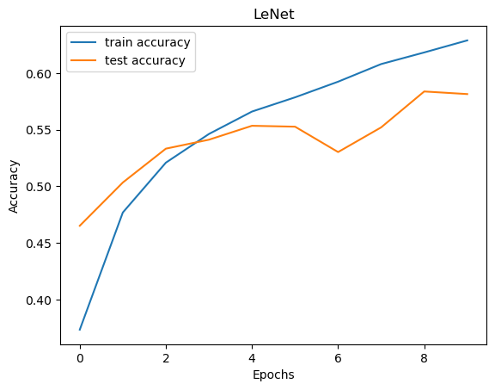
Training VGGNet...
Epoch 1/10
782/782 ━━━━━━━━━━━━━━━━━━━━ 701s 887ms/step - accuracy: 0.1004 - loss: 2.3051 - val_accuracy: 0.1000 - val_loss: 2.3027
Epoch 2/10
782/782 ━━━━━━━━━━━━━━━━━━━━ 671s 858ms/step - accuracy: 0.0989 - loss: 2.3029 - val_accuracy: 0.1000 - val_loss: 2.3026
Epoch 3/10
782/782 ━━━━━━━━━━━━━━━━━━━━ 665s 851ms/step - accuracy: 0.0964 - loss: 2.3028 - val_accuracy: 0.1000 - val_loss: 2.3026
Epoch 4/10
782/782 ━━━━━━━━━━━━━━━━━━━━ 667s 853ms/step - accuracy: 0.0992 - loss: 2.3027 - val_accuracy: 0.1000 - val_loss: 2.3026
Epoch 5/10
782/782 ━━━━━━━━━━━━━━━━━━━━ 668s 854ms/step - accuracy: 0.1006 - loss: 2.3027 - val_accuracy: 0.1000 - val_loss: 2.3026
Epoch 6/10
735/782 ━━━━━━━━━━━━━━━━━━━━ 38s 821ms/step - accuracy: 0.1003 - loss: 2.3027
import os
import pickle
import numpy as np
import tensorflow as tf
from tensorflow.keras import layers, models
import matplotlib.pyplot as plt
# Set path for CIFAR-10 dataset
cifar10_path = "E:\Soft Computing Lab\cifar-10-batches-py" # Ensure this path is correct"E:\Soft Computing Lab\cifar-10-batches-py"
# Ensure that the files exist in the specified directory
if not os.path.exists(cifar10_path):
raise FileNotFoundError(f"The specified path does not exist: {cifar10_path}")
# Function to load CIFAR-10 dataset manually
def load_cifar10_data(path):
x_train, y_train, x_test, y_test = [], [], [], []
# Load training data
for i in range(1, 6):
file_path = os.path.join(path, f"data_batch_{i}")
if not os.path.isfile(file_path):
raise FileNotFoundError(f"File not found: {file_path}")
with open(file_path, 'rb') as f:
batch = pickle.load(f, encoding='bytes')
x_train.append(batch[b'data'])
y_train += batch[b'labels']
x_train = np.concatenate(x_train)
x_train = x_train.reshape(-1, 3, 32, 32).transpose(0, 2, 3, 1) # Convert to (32, 32, 3)
y_train = np.array(y_train)
# Load test data
test_file_path = os.path.join(path, 'test_batch')
if not os.path.isfile(test_file_path):
raise FileNotFoundError(f"File not found: {test_file_path}")
with open(test_file_path, 'rb') as f:
batch = pickle.load(f, encoding='bytes')
x_test = batch[b'data']
y_test = batch[b'labels']
x_test = x_test.reshape(-1, 3, 32, 32).transpose(0, 2, 3, 1) # Convert to (32, 32, 3)
y_test = np.array(y_test)
return (x_train, y_train), (x_test, y_test)
# Load CIFAR-10 dataset from the specified path
(x_train, y_train), (x_test, y_test) = load_cifar10_data(cifar10_path)
# Normalize images
x_train, x_test = x_train / 255.0, x_test / 255.0
y_train, y_test = tf.keras.utils.to_categorical(y_train, 10), tf.keras.utils.to_categorical(y_test, 10) # One-hot encode labels
# Function to plot training history
def plot_history(history, title):
plt.plot(history.history['accuracy'], label='train accuracy')
plt.plot(history.history['val_accuracy'], label='test accuracy')
plt.title(title)
plt.xlabel('Epochs')
plt.ylabel('Accuracy')
plt.legend()
plt.show()
# VGGNet Model
def build_vggnet():
model = models.Sequential()
model.add(layers.Conv2D(64, (3, 3), activation='relu', padding='same', input_shape=(32, 32, 3)))
model.add(layers.Conv2D(64, (3, 3), activation='relu', padding='same'))
model.add(layers.MaxPooling2D((2, 2)))
model.add(layers.Conv2D(128, (3, 3), activation='relu', padding='same'))
model.add(layers.Conv2D(128, (3, 3), activation='relu', padding='same'))
model.add(layers.MaxPooling2D((2, 2)))
model.add(layers.Conv2D(256, (3, 3), activation='relu', padding='same'))
model.add(layers.Conv2D(256, (3, 3), activation='relu', padding='same'))
model.add(layers.Conv2D(256, (3, 3), activation='relu', padding='same'))
model.add(layers.MaxPooling2D((2, 2)))
model.add(layers.Conv2D(512, (3, 3), activation='relu', padding='same'))
model.add(layers.Conv2D(512, (3, 3), activation='relu', padding='same'))
model.add(layers.Conv2D(512, (3, 3), activation='relu', padding='same'))
model.add(layers.MaxPooling2D((2, 2)))
model.add(layers.Conv2D(512, (3, 3), activation='relu', padding='same'))
model.add(layers.Conv2D(512, (3, 3), activation='relu', padding='same'))
model.add(layers.Conv2D(512, (3, 3), activation='relu', padding='same'))
model.add(layers.MaxPooling2D((2, 2)))
model.add(layers.Flatten())
model.add(layers.Dense(4096, activation='relu'))
model.add(layers.Dropout(0.5))
model.add(layers.Dense(4096, activation='relu'))
model.add(layers.Dropout(0.5))
model.add(layers.Dense(10, activation='softmax'))
return model
# ResNet Model
def build_resnet():
def resnet_block(x, filters):
shortcut = x
x = layers.Conv2D(filters, (3, 3), padding='same')(x)
x = layers.BatchNormalization()(x)
x = layers.ReLU()(x)
x = layers.Conv2D(filters, (3, 3), padding='same')(x)
x = layers.BatchNormalization()(x)
x = layers.add([x, shortcut])
x = layers.ReLU()(x)
return x
input_tensor = layers.Input(shape=(32, 32, 3))
x = layers.Conv2D(16, (3, 3), padding='same')(input_tensor)
x = layers.BatchNormalization()(x)
x = layers.ReLU()(x)
for _ in range(3):
x = resnet_block(x, 16)
x = layers.GlobalAveragePooling2D()(x)
x = layers.Dense(10, activation='softmax')(x)
model = models.Model(input_tensor, x)
return model
# Compile and train models
def train_model(model, model_name):
model.compile(optimizer='adam', loss='categorical_crossentropy', metrics=['accuracy'])
history = model.fit(x_train, y_train, epochs=10, batch_size=64, validation_data=(x_test, y_test), verbose=1)
plot_history(history, model_name)
return model.evaluate(x_test, y_test, verbose=0)
# Main execution
def main():
models_dict = {
"VGGNet": build_vggnet(),
"ResNet": build_resnet(),
}
results = {}
for name, model in models_dict.items():
print(f"Training {name}...")
results[name] = train_model(model, name)
print("\nModel Comparison (Test Loss and Accuracy):")
for name, (loss, accuracy) in results.items():
print(f"{name}: Loss = {loss:.4f}, Accuracy = {accuracy:.4f}")
if __name__ == "__main__":
main()
<>:9: SyntaxWarning: invalid escape sequence '\S'
<>:9: SyntaxWarning: invalid escape sequence '\S'
C:\Users\136442\AppData\Local\Temp\ipykernel_6820\277813782.py:9: SyntaxWarning: invalid escape sequence '\S'
cifar10_path = "E:\Soft Computing Lab\cifar-10-batches-py" # Ensure this path is correct"E:\Soft Computing Lab\cifar-10-batches-py"
C:\Users\136442\anaconda3\Lib\site-packages\keras\src\layers\convolutional\base_conv.py:107: UserWarning: Do not pass an `input_shape`/`input_dim` argument to a layer. When using Sequential models, prefer using an `Input(shape)` object as the first layer in the model instead.
super().__init__(activity_regularizer=activity_regularizer, **kwargs)
Training VGGNet...
Epoch 1/10
782/782 ━━━━━━━━━━━━━━━━━━━━ 1598s 2s/step - accuracy: 0.0986 - loss: 2.3039 - val_accuracy: 0.1000 - val_loss: 2.3027
Epoch 2/10
782/782 ━━━━━━━━━━━━━━━━━━━━ 1602s 2s/step - accuracy: 0.1002 - loss: 2.3028 - val_accuracy: 0.1000 - val_loss: 2.3026
Epoch 3/10
782/782 ━━━━━━━━━━━━━━━━━━━━ 1587s 2s/step - accuracy: 0.0952 - loss: 2.3027 - val_accuracy: 0.1000 - val_loss: 2.3026
Epoch 4/10
782/782 ━━━━━━━━━━━━━━━━━━━━ 1592s 2s/step - accuracy: 0.0982 - loss: 2.3027 - val_accuracy: 0.1000 - val_loss: 2.3026
Epoch 5/10
782/782 ━━━━━━━━━━━━━━━━━━━━ 1590s 2s/step - accuracy: 0.0970 - loss: 2.3027 - val_accuracy: 0.1000 - val_loss: 2.3026
Epoch 6/10
782/782 ━━━━━━━━━━━━━━━━━━━━ 1571s 2s/step - accuracy: 0.0971 - loss: 2.3027 - val_accuracy: 0.1000 - val_loss: 2.3026
Epoch 7/10
782/782 ━━━━━━━━━━━━━━━━━━━━ 1607s 2s/step - accuracy: 0.0962 - loss: 2.3027 - val_accuracy: 0.1000 - val_loss: 2.3026
Epoch 8/10
782/782 ━━━━━━━━━━━━━━━━━━━━ 1595s 2s/step - accuracy: 0.0987 - loss: 2.3027 - val_accuracy: 0.1000 - val_loss: 2.3026
Epoch 9/10
782/782 ━━━━━━━━━━━━━━━━━━━━ 1591s 2s/step - accuracy: 0.0982 - loss: 2.3027 - val_accuracy: 0.1000 - val_loss: 2.3026
Epoch 10/10
782/782 ━━━━━━━━━━━━━━━━━━━━ 2868s 4s/step - accuracy: 0.0981 - loss: 2.3027 - val_accuracy: 0.1000 - val_loss: 2.3026
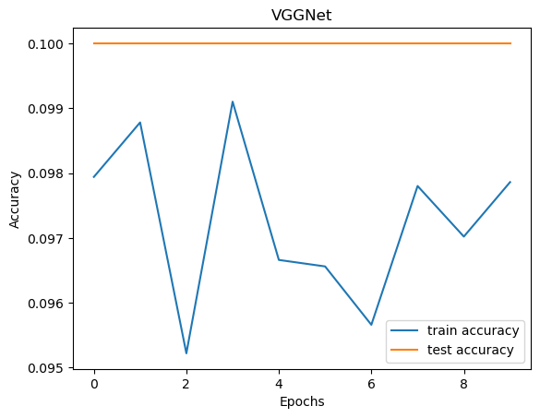
Training ResNet...
Epoch 1/10
782/782 ━━━━━━━━━━━━━━━━━━━━ 271s 315ms/step - accuracy: 0.3254 - loss: 1.8661 - val_accuracy: 0.3652 - val_loss: 1.7034
Epoch 2/10
782/782 ━━━━━━━━━━━━━━━━━━━━ 283s 342ms/step - accuracy: 0.5039 - loss: 1.3904 - val_accuracy: 0.4922 - val_loss: 1.3873
Epoch 3/10
782/782 ━━━━━━━━━━━━━━━━━━━━ 287s 296ms/step - accuracy: 0.5605 - loss: 1.2322 - val_accuracy: 0.5412 - val_loss: 1.2365
Epoch 4/10
782/782 ━━━━━━━━━━━━━━━━━━━━ 237s 303ms/step - accuracy: 0.5945 - loss: 1.1368 - val_accuracy: 0.4101 - val_loss: 1.7565
Epoch 5/10
782/782 ━━━━━━━━━━━━━━━━━━━━ 284s 332ms/step - accuracy: 0.6186 - loss: 1.0771 - val_accuracy: 0.5453 - val_loss: 1.2409
Epoch 6/10
782/782 ━━━━━━━━━━━━━━━━━━━━ 271s 343ms/step - accuracy: 0.6327 - loss: 1.0321 - val_accuracy: 0.4952 - val_loss: 1.4412
Epoch 7/10
782/782 ━━━━━━━━━━━━━━━━━━━━ 283s 293ms/step - accuracy: 0.6465 - loss: 0.9863 - val_accuracy: 0.4144 - val_loss: 2.0749
Epoch 8/10
782/782 ━━━━━━━━━━━━━━━━━━━━ 264s 295ms/step - accuracy: 0.6583 - loss: 0.9597 - val_accuracy: 0.4408 - val_loss: 1.5521
Epoch 9/10
782/782 ━━━━━━━━━━━━━━━━━━━━ 233s 298ms/step - accuracy: 0.6650 - loss: 0.9357 - val_accuracy: 0.6147 - val_loss: 1.0806
Epoch 10/10
782/782 ━━━━━━━━━━━━━━━━━━━━ 252s 322ms/step - accuracy: 0.6732 - loss: 0.9137 - val_accuracy: 0.4946 - val_loss: 1.7611
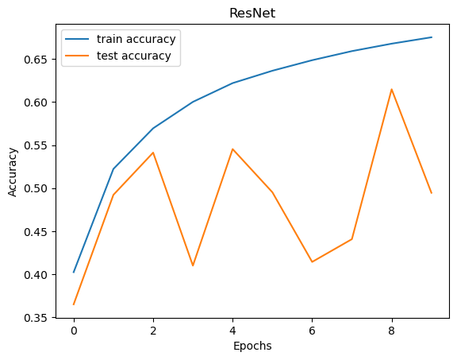
Model Comparison (Test Loss and Accuracy):
VGGNet: Loss = 2.3026, Accuracy = 0.1000
ResNet: Loss = 1.7611, Accuracy = 0.4946

